Shadow

📘 Definition
# Source: AI Source: Provided by: [Data Path: Persons Table -> ID Column: 1, Name_En Column: Motasem Essam] -> From: [ChatGPT] on [5/2/2026]
A shadow is a dark area that appears when an object blocks light from a light source.

🌑 How shadows are formed
# Source: AI Source: Provided by: [Data Path: Persons Table -> ID Column: 1, Name_En Column: Motasem Essam] -> From: [ChatGPT] on [5/2/2026]
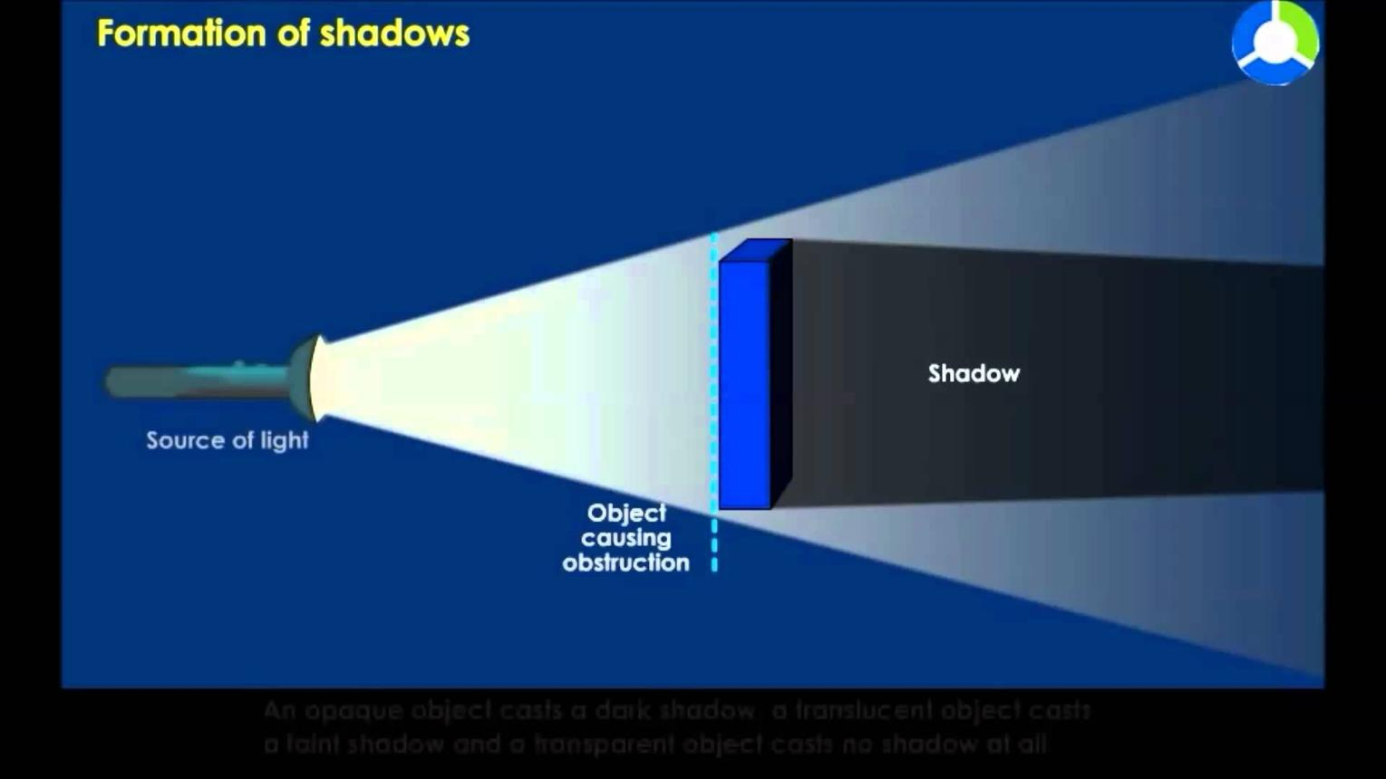
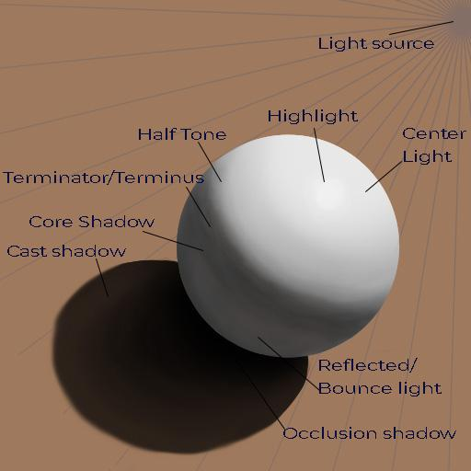
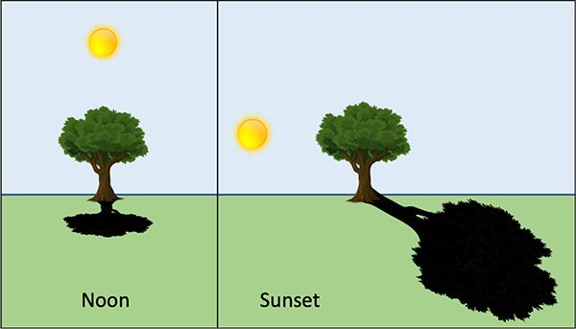
- Light travels from a light source
- An object blocks the light
- The blocked area becomes a shadow

🧠 Simple example
# Source: AI Source: Provided by: [Data Path: Persons Table -> ID Column: 1, Name_En Column: Motasem Essam] -> From: [ChatGPT] on [5/2/2026]
Think of:
- ☀️ Standing in sunlight → your body creates a shadow on the ground
- 💡 Putting your hand in front of a lamp → a shadow appears behind it

🎮 Shadow in computer graphics
# Source: AI Source: Provided by: [Data Path: Persons Table -> ID Column: 1, Name_En Column: Motasem Essam] -> From: [ChatGPT] on [5/2/2026]
In graphics, shadows are created to make scenes look realistic by showing:
- Depth (distance between objects)
- Shape of objects
- Position of light sources

⚙️ Types of shadows
# Source: AI Source: Provided by: [Data Path: Persons Table -> ID Column: 1, Name_En Column: Motasem Essam] -> From: [ChatGPT] on [5/2/2026]
- Hard shadow → sharp, clear edges
- Soft shadow → blurry, smooth edges
# Source: Table Source: Provided by: [Data Path: Persons Table -> ID Column: 1, Name_En Column: Motasem Essam] From: [Data Path: Miscellaneous Folder -> Miscellaneous Database -> Miscellaneous Table -> ID: 39] on [5/2/2026]

🚀 In short:
# Source: AI Source: Provided by: [Data Path: Persons Table -> ID Column: 1, Name_En Column: Motasem Essam] -> From: [ChatGPT] on [5/2/2026]
Shadow = a dark area formed when light is blocked by an object.

